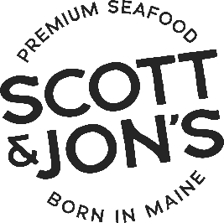
Scott & Jon's Takes on Shrinkflation: Now Shipping Meals with 20% More Food!
[Auburn, Maine] – [February 14, 2024] – FOR IMMEDIATE RELEASE - Scott & Jon's, the leader in healthy, premium seafood meals, announced that it is now shipping larger portions of their popular shrimp bowls while maintaining pricing at the store to uphold its commitment to fight shrinkflation. Late last month, stores began receiving shrimp bowls with 20% more product, going from 8.0 oz to 9.6 oz. Furthermore, the newly launched salmon bowls line also features 9.6 oz of premium seafood and other high-quality ingredients. These initiatives underscore the company's dedication to providing value to consumers amidst market challenges.
Jon Demers, Co-Founder of Scott & Jon's, expressed enthusiasm about the company's decision, stating: "At Scott & Jon's, we prioritize the satisfaction of our consumers above all else. By increasing the size of our bowls without increasing the price, we are demonstrating our commitment to providing exceptional value and quality. We refuse to compromise on either, even in the face of industry challenges like shrinkflation. Our consumers deserve the best."
The decision to enlarge the portion sizes of these popular meals reflects Scott & Jon's unwavering dedication to premium seafood and consumer satisfaction. By maintaining the same price point while offering more product in every bowl, the company aims to ensure that its customers can continue to enjoy delicious, nutritious seafood meals without feeling shortchanged.
The increased-size shrimp and salmon bowls are beginning to ship to retailers nationwide. Actual shipment dates will vary by retailer depending upon existing inventories. Consumers can expect to see the larger portions on shelves and online platforms in the coming weeks.
About Scott & Jon's:
Founded by brothers Scott and Jon Demers, Scott & Jon's is a Maine-based company dedicated to transforming the frozen food aisle with its premium seafood meals. Inspired by family recipes, they set out to create meals that were both delicious and healthy, challenging the notion that convenient melas had to be bland or nutritionally lacking.
Their commitment to quality and flavor has earned Scott & Jon's a loyal following and recognition from industry experts. The brand's products are available in major grocery stores nationwide, bringing a taste of Maine to kitchens across the country. To learn more and find Scott & Jon’s in a store near you, visit www.scottandjons.com.
Contact: Mark Ozimek, mark@scottandjons.com

