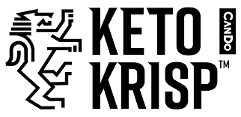

**FOR IMMEDIATE RELEASE**

**Keto Krisp® by CanDo Expands Plant-Based Line with Launch of Peanut Butter Chocolate Chunk in Whole Foods Nationwide**

*Since being named the #1-selling bar brand in Whole Foods SoPac and becoming the fastest-growing bar brand in the natural channel, this year, the company will roll out to Whole Foods nationwide with six SKU’s, as it continues to innovate with products that excite fans and meet growing consumer demand for keto-friendly, on-the-go options*

**Los Angeles, Calif. August 2, 2021** – Keto Krisp® by CanDo ([www.tastecando.com](http://www.tastecando.com)), a line of low-carb, low-sugar and delicious-tasting keto bars, is taking its plant-powered offerings to the next level, announcing today the launch of its newest flavor: Plant-Based Peanut Butter Chocolate Chunk. After claiming the top spot of #1-selling bar brand in Whole Foods SoPac, Keto Krisp will be rolling out six SKU’s in Whole Foods Nationwide, this month, including this latest plant-based innovation.

Following the launch of its first plant-based flavor, Almond Butter Blackberry Jelly, Keto Krisp’s Peanut Butter Chocolate Chunk will be the first peanut-based, plant-protein offering, delivering a salty-sweet, decadent combination of, creamy peanut butter, rich chocolate, soy protein, MCT oil and other keto-friendly ingredients. The new flavor will be available online at [www.tastecando.com](http://www.tastecando.com) ($35.99/12-pack) and in Whole Foods nationwide (SRP: $2.99/bar), this month.

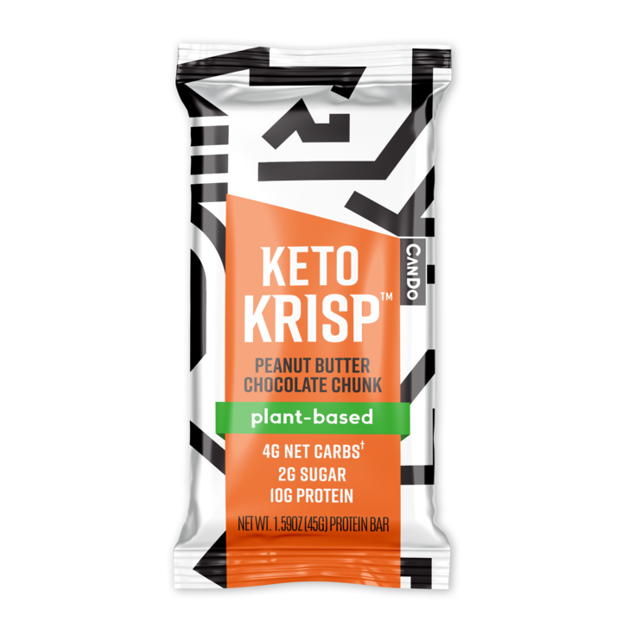

In addition to its success the #1-selling Keto Bar in Sprouts, Wegmans and Publix, and the #1-rated Keto bar on Amazon, Keto Krisp is continuing its expansion into additional channels, while increasing its SKU offerings in existing banners.

With only a few years since launching its line of optimal-protein keto bars, the startup has been on a mission to deliver on taste, ingredients and nutrition, while remaining steadfast in supporting and connecting with its consumers to instill the CanDo ethos, brought to by founder [Adam Bremen](https://tastecando.com/pages/about-us). The result: A fast-paced upward trajectory and unmatched fan loyalty that, most recently, has Keto Krisp significantly contributing to both the growth of the entire bar category, at 17%*, and growing 600% YoY, as a brand.

In building this momentum, CanDo has attracted investors and talent with vast and diverse industry experience, completing a round of fundraising from noteworthy CPG and startup veterans, including:

* Enlightened Access Capital, Nicholas Giannuzzi and Ryan Lewendon;
* Shane Emmet, Founder of Health Warrior;
* Justin Kan, Founder of Twitch;
* Rodeo Capital, Rodeo CPG Investment Arm;
* and Ari Raz, Co-Founder and President of Once Upon and Farm

Keto Krisp’s current line of low-sugar, low-carb flavors, including Almond Butter Chocolate Chip, Almond Butter, Chocolate Mint, Chocolate Raspberry and Plant-Based Almond Butter Blackberry Jelly are available online at [www.tastecando.com](http://www.tastecando.com) and in-store at Whole Foods SoPac, Wegmans, H-E-B, Harris Teeter and Publix and Sprouts, with more retail partners announced soon.

For more information, visit [www.tastecando.com](http://www.tastecando.com)

1. 24 WEEK SPINS NATURAL (KETO KRISP DOLLARS / TOTAL POSITIVE DOLLARS)
2. 24 WEEK $$/ TDP IN WFM APRIL 2021 NIELSEN DATA
3. 24 WEEK $$/TDP IN SPROUTS APRIL 2021 SPINS DATA
4. 24 WEEK VELOCITY DATA WEGMANS OCTOBER 2020
5. HIGHEST-AMAZON RATING OF ALL KETO PROTEIN BARS, AS OF AUGUST 2020

**About CanDo:**

CanDo ([www.tastecando.com](http://www.tastecando.com)) is driven by a mission to inspire and empower a community of doers, dreamers and believers to live a healthier, more-fulfilling lifestyle, every day.

Founder Adam Bremen was born with Cerebral Palsy and has used an electric wheelchair for mobility his entire life. From an early age, he was instilled with the mentality that, “Life would always be about you CanDo, not about what you can’t.”

Keto Krisp is the result of Bremen’s weight-loss journey, after discovering and adopting the Keto lifestyle, and the search of a delicious, on-the-go snack he couldn’t find on the market. Keto Krisp’s line of low-sugar, low-carb protein bars is the perfect combination of premium nutrition, unrivaled taste and a crave-worthy crunch that puts it in a league of its own.

Together, with CanDo’s products and commitment to empowering its community, they’re committed to being there every step of the way.

It’s about what you CanDo.

For more information, visit [www.tastecando.com](http://www.tastecando.com)

**About Adam Bremen, Founder of CanDo**

My name is Adam Bremen and I am the Founder of CanDo - maker of Keto Krisp protein bars!

At CanDo, our mission is to inspire and empower everyone to live a healthier lifestyle every day.

Why? I was born with Cerebral Palsy and have used an electric wheelchair to move around my entire life. From an early age, my parents instilled in me that life is about what I CAN DO, not what I can’t do.

It is this very spirit that propels us forward, pushes us to seek better, do better.

And it is this spirit that defines our drive to make the best products we can.

At 42, I was overweight and needed to make a change. I transitioned to a keto-based diet and began exercising daily. I lost 65lbs! During my weight loss journey, I couldn't find an on-the-go snack that tasted good. So, I created Keto Krisp, the perfect combination of a protein bar with an unrivaled taste and premium nutritional ingredients.

After all, life's too short to eat sh##y tasting bars.

Today, we at CanDo invite you to join the tribe, whether Keto or not, and embody the CanDo spirit.

To do, instead of dream. To decide to live the way you want.

And together, with our products and commitment to empowering our community, will be there every step of the way.

It’s about what you CanDo,

-Adam Bremen