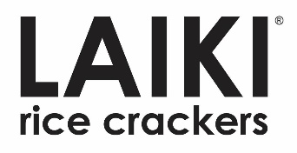
For Immediate Release:
Leila Belcher of LJB PR
Leila@LJBPublicRelations.com
303-345-1805

Former Bare Snacks CEO Invests in Laiki Crackers & Joins Board of Directors

San Francisco, CA - LAIKI Inc. closed its Series A1 equity round and welcomed Santosh Padki to its Board of Directors. Santosh was recently the CEO of Bare Snacks, the iconic plant-based snacking brand, which was acquired by PepsiCo. Santosh has held senior leadership roles at high growth consumer products companies after acquiring his brand-building experiences at ConAgra and Sara Lee. "Pradeep and his team are building a high potential brand with products that strongly resonate with the growing consumer demand for crunchy, clean-label, better for you snacks," said Santosh Padki. "I look forward to helping them build the LAIKI brand."
LAIKI offers wholesome, nutrient-dense, better-for-you crackers, made from 100% whole grain rice, in unique black and red varieties. Its deliciously crunchy crackers are vegan, gluten-free, and free from key allergens.
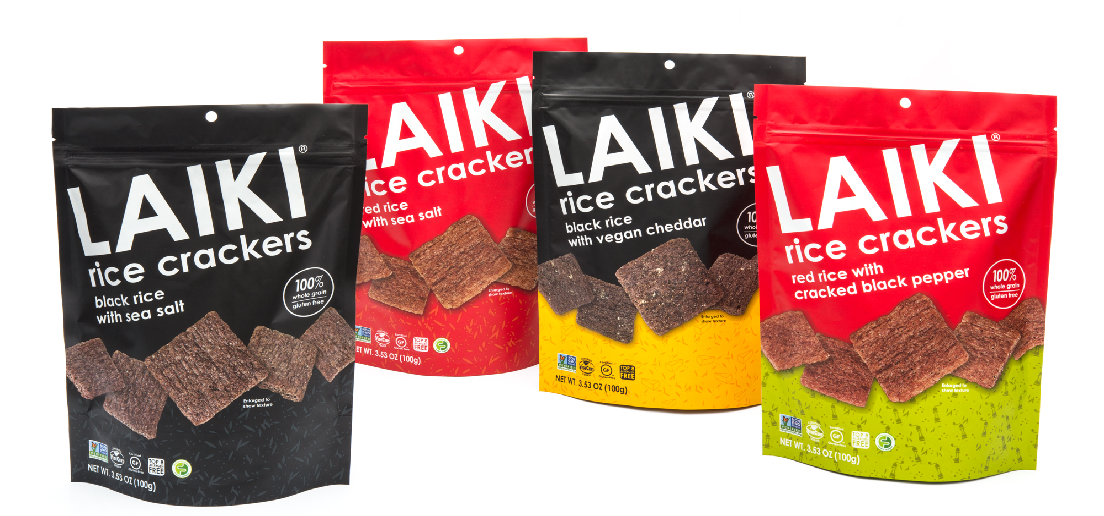

"We are excited for our next stage of growth and are fortunate to leverage the experience of Santosh as we bring LAIKI to more consumers across North America," Pradeep Akkunoor, Founder of LAIKI Crackers, stated.

Aside from Santosh, the Series A sole investor, board member John Crean, Managing Member of Sonoma Equity Partners, fully participated in the round. "LAIKI has shown significant progress since our original investment, and we are pleased to welcome Santosh on board and to participate to our full share in Series A1," said Crean.
The team was also recently strengthened by the addition of Tony Sisneros, a former Sales Director at General Mills. His efforts have been focused on building new distribution within natural, specialty, and grocery channels. Under his leadership, LAIKI has rapidly expanded store count from 1,000 to over 6,000 US locations.
LAIKI crackers come in a popular 3.5oz resealable standup pouch and have an SRP of $3.49. Laiki Crackers are available online at www.laikicrackers.com and are available in over 6,000 stores including Sprouts, Albertsons/Safeway, HEB, HyVee, Wegmans, Whole Foods, and many other key retailers across the U.S. and Canada.

