Contact Information:
Ana Goettsch Kelsey Spencer
PRIMAL KITCHEN® The Narrative Group
ana@primalkitchen.com kelsey.spencer@narrativemediagroup.com

For immediate release

PRIMAL KITCHEN® INTRODUCES A NEW LINE OF PASTA SAUCES
New Marinara and No-Dairy Alfredo and No-Dairy Vodka Sauces
Made with Avocado Oil
OXNARD, CA (9/9/2019) - On the heels of the launch of bestselling PRIMAL KITCHEN® Organic and Unsweetened BBQ Sauces and innovative No Soy Teriyaki Sauce and Marinade, PRIMAL KITCHEN is adding a pasta sauce collection to their portfolio. Their new pasta sauce lineup includes five delicious flavors: Tomato Basil Marinara Sauce, Roasted Garlic Marinara Sauce, No-Dairy Alfredo Sauce, No-Dairy Garlic Alfredo Sauce and No-Dairy Vodka Sauce.
The Alfredo sauces made without dairy are Certified Keto, plant-based white sauces made with avocado oil, instead of the traditional canola or soybean oil. The no-dairy secret to our velvety sauce? It’s creamy cashew butter with roasted garlic and onion, topped with flavorful black pepper. Also featuring creamy cashew butter, the Vodka Sauce is Certified Paleo, plant-based and vegan, made with avocado oil, bold garlic, oregano and basil, and organic California-grown tomatoes. It is a new and unique twist on the traditional heavy cream-based vodka sauces.

Tomato Basil and Roasted Garlic Marinaras also get a PRIMAL KITCHEN upgrade with organic, California-grown tomatoes, avocado oil, and no added sugar. Both varieties are Certified-Paleo, plant-based and Whole30® Approved sauces.

“I’m thrilled about our new PRIMAL KITCHEN line of pasta sauces and the delicious variety they offer. From the innovative cashew butter creaminess in the vegan Alfredos and Vodka Sauce to organic, California-grown tomatoes in the marinaras, this line offers real food consumers of every lifestyle (from keto to plant-based) clean, Italian-inspired options,” states founder, Mark Sisson. “It’s another example of ways consumers can enjoy PRIMAL KITCHEN with all the flavor and the same promise of exceptional quality—no gluten, grains, added or refined sugar, soy or canola oils, or artificial ingredients.”

As a leader in natural grocery focusing on clean, simple ingredients, PRIMAL KITCHEN was named “2019 Best Paleo Company” in both the Food and Lifestyle categories by Paleo Magazine. The addition of pasta sauces was a natural fit for the brand, which prides itself on offering a vast portfolio of products that started with avocado oil-based mayo and quickly grew to a variety of dressings and marinades, condiments, sauces, avocado oil, and pantry staples.

PRIMAL KITCHEN Pasta Sauces are sold in 16-oz. or 24-oz. bottles for a suggested retail price of $8.99 per jar and are available in August 2019 at primalkitchen.com. Sauces will be available at retailers nationwide and on Thrive Market in the fall of 2019.

Pair any of our plant-based, vegan, and Certified Paleo sauces with zoodles, casseroles, chicken or Italian-inspired eats for an uncompromisingly delicious upgrade.

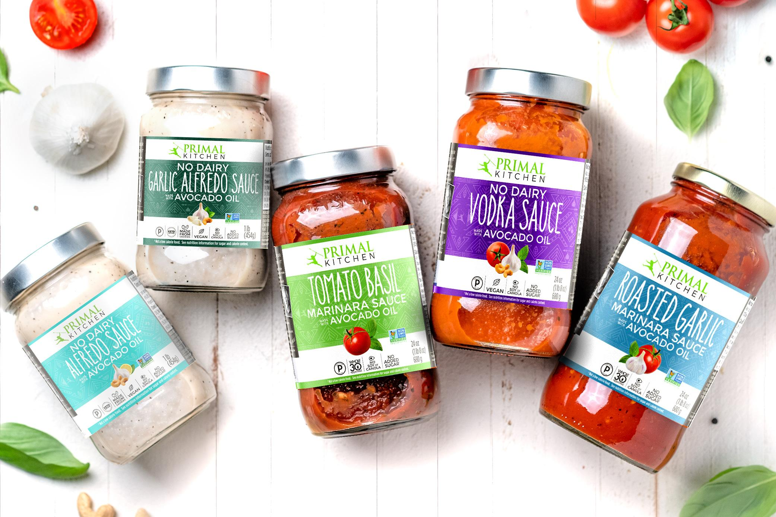

About Mark Sisson & PRIMAL KITCHEN®

Mark Sisson, New York Times bestselling author, media personality, ex-endurance athlete (5th place USA Marathon Championship, 4th place Hawaii Ironman finish) founded the PRIMAL KITCHEN® brand in 2015. He has been educating the world on nutrition and the benefits of fat and protein for the last decade via his blog, MarksDailyApple.com.

With the launch of the PRIMAL KITCHEN® brand, Mark Sisson delivers on his mission to create uncompromisingly delicious condiments, sauces, cooking oils, collagen protein and pantry staples that are full of fats we love and simple ingredients, and contain no dairy, gluten, grain, refined or added sugar or soy. PRIMAL KITCHEN is the maker of the #1 condiment in natural grocery, the #1 salad dressing brand in natural grocery, and #1 product in six key condiment categories in natural grocery: mayo, salad dressing, BBQ sauce, steak sauce, ketchup and avocado oil.* As Mark would say, Eat Like Your Life Depends on It, because it does. Learn more at primalkitchen.com.

###
*Source: SPINSScan Natural Channel, SS Mayonnaise, SS Dressing, SS Ketchup, SS Mustard, SS BBQ Sauce, SS Cooking Sauce & Other Condiments, SS Culinary Oil Flavored and Speciality, 24 Weeks Ending 8/11/19

