FOR IMMEDIATE RELEASE

Stacey Bender

[Stacey@bendergrouppr.com](mailto:Stacey@bendergrouppr.com)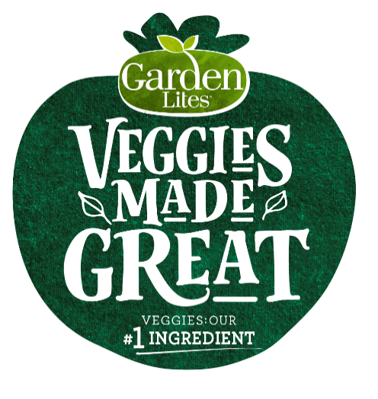

***Veggies Made Great by Garden Lites®* Adds Delicious Flavors To Their**

**Wildly Popular, New Frittatas Line**

**RAHWAY, NJ (May -- 2019)** – ***Veggies Made Great*** by ***Garden Lites*®,** the leader in unique veggie-rich foods, brings two new flavors of **Frittatas** to Costco stores: **Broccoli Cheddar Frittatas** and **Mushroom & 3 Cheese Egg White Frittatas**. These two new flavors join the incredibly successful **Spinach Egg White Frittata** and **Veggie Bacon, Potato & Egg Frittata**~~.~~ ***Veggies Made Great* Frittatas**are expected to keep pace with the #1 selling product **Superfood Veggie Cakes**,and are set to exceed $15M in annual sales in 2019, in their first year in the market.

***Veggies Made Great* Frittatas** made with cage free eggs meet the growing consumer demand for healthy plant based food, making them the perfect breakfast; nutritious, delicious, and convenient. They are a wonderful alternative to your typical breakfast, offering veggie-rich, high protein and clean ingredients that are quick and easy to prepare in a microwave or toaster oven. Like all the items from ***Veggies Made Great***, veggies are the #1 ingredient, they are Gluten Free, and remarkably delicious.

Consumers can find ***these 20 count Frittatas*** in the freezer section at **Costco** stores over the next several months and sample them for free at participating Costcos from **May 8- May 11** and **May 30 - June 2**. For participating locations, please visit www.veggiesmadegreat.com/storelocator.

***Veggies Made Great by Garden Lites*** continues to innovate as they grow and adapt their delicious line of veggie-rich foods. **Broccoli Cheddar Frittatas** are only 90 calories, 5 grams of Protein, and Gluten Free. The **Mushroom & 3 Cheese Egg White Frittatas** are only 80 calories, 5 grams of protein and Gluten Free.

Andy Reichgut, Executive Vice President of ***Garden Lites***,says, “We’re thrilled to bring two new flavors of **Frittatas** to this already wildly popular and powerful breakfast category line! These new ***Veggies Made Great products*** continue our mission to create the highest quality, remarkably delicious and nutritionally smart veggie-rich foods that are ready to eat and available everywhere.

Other ***Veggies Made Great*** products includethe very popular and remarkably delicious **Muffins** and the best-selling **Superfood Veggie Cakes.** The**Muffins** aremade with fresh zucchini and carrotsand include flavors such as **Blueberry Oat,Double Chocolate, Banana Chocolate Chip and Cranberry Orange**. Muffins can be found in the freezer section of Costco. **Superfood Veggie Cakes** are packed with nutrient-rich superfood veggies like kale and cauliflower and make a great breakfast, snack or side dish, and are available in the Costco refrigerated section.

**All *Veggies Made Great*** products can be found nationwide, including distribution in Costco, Kroger, Target, Shop Rite, Publix, Stop & Shop, Giant, Meijer, HEB, Ralph’s, Fry’s, The Fresh Market, and many more retailers. For coupons and information on where to buy, please visit www.veggiesmadegreat.com/storelocator.

**About *Veggies Made by GreatGarden Lites* ®:**

***Veggies Made Great by Garden Lites*** ® is a New Classic Cooking, LLC brand based in Avenel and Rahway, NJ. Since 2008, ***Veggies Made Great by* Garden Lites** has raised the bar in healthy foods by delivering surprisingly delicious veggie-rich foods. Garden Lites is the recipient of numerous awards, including; Women’s Health Top Health Picks; Cooking Light - The Healthiest Frozen Foods in the Supermarket: Breakfast; Grocery Headquarters Trailblazer Award; Parents Magazine 25 Best Frozen Food for Families; Gluten Free Digest Chocolate Muffins; 2015 Pioneers of Better For You: Refrigerated and Frozen Foods and Runner’s World Editor’s Pick.