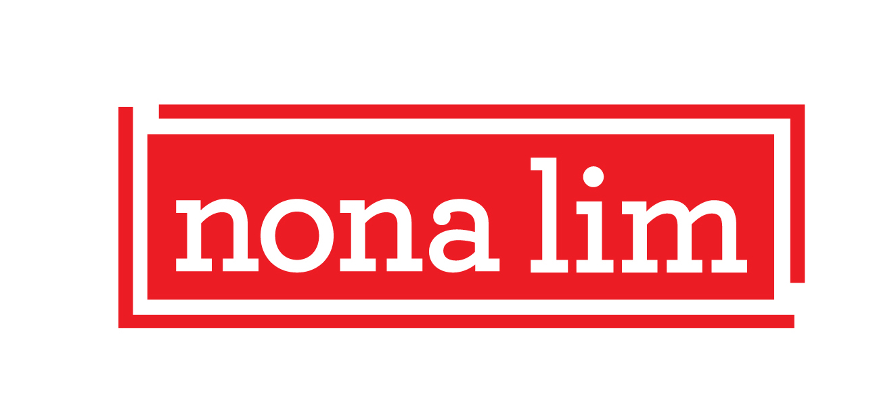

Contact: Melissa Gibson, Krupa Consulting **FOR IMMEDIATE RELEASE**

Melissa@krupaconsulting.com/ t. 323.656.6995

**NONA LIM DEBUTS FRESH NEW LOOK AND PRODUCTS**

*New Noodle Bowl, Soup, and Broths Take Center Stage at the Natural Products Expo West®*

**Los Angeles, CA (March 5, 2019)** – California-based [**Nona Lim**](https://www.nonalim.com/),the most convenient way to enjoy fresh, clean label, nutrient-dense Asian comfort food like broths, soups, and noodles, has announced a colorful elevated packaging rebrand and five new product varieties. **Nona Lim** will debut its playful new look and products at the **Natural Products Expo West**®.

Founder **Nona Lim’s** Singaporean heritage drives the brand’s obsession with authentic flavor and serves as the platform for its continued exploration of the delicious cuisines found throughout Asia. The rebrand will more clearly position Nona Lim’s products in the marketplace by visually speaking to this heritage. “The more colorful packaging design draws inspiration from the diversity of Asian cultures found within Singapore, a beautiful melting pot of cultures and cuisines, and the region, but with a modern take,” said Nona Lim. “Our new packaging and product additions embody the flavors, creativity, and vitality found in these colorful, fresh foods.”

Complex and savory, **Nona Lim’s** newest products, found in the refrigerator section, add even more flavor and size variety to its exclusively preservative- and MSG-free line:

**Spicy Miso Ramen Bowl:** A hearty ramen broth similar to Japanese tonkotsu made with organic chicken bone broth, miso, chili-fermented soybeans, and organic soy milk, paired with fresh ramen noodles with just the right bite in a 14.5oz grab-and-go bowl (dairy-free)

**Indian Lentil Soup:** High protein and full of traditional Indian spices - toasted cumin, coriander, and turmeric - in a convenient 10oz heat-and-sip cup (vegan, gluten- and dairy-free, and non-GMO)

**Spicy Miso Ramen Broth:** A creamy, hearty chicken-based ramen broth made with organic chicken bone broth, red miso, chili bean paste, and organic soy milk in a new 20oz pouch with a pourable spout (gluten- and dairy-free)

**Shitake Beef Bone Broth:** Now available in both a 20oz pouch, as well as in a heat-and-sip cup, organic beef bones are slow-simmered with ginger and shiitake mushrooms (gluten- and dairy-free, paleo and keto friendly)

**Turmeric Chicken Bone Broth**: Now available in both a 20 oz pouch, as well as in a heat-and-sip cup, organic chicken bone broth is slow-simmered with turmeric, ginger, and goji berries (gluten- and dairy-free, paleo- and keto friendly)

**Nona Lim’s** new products ($3.99-8.99 MSRP) will be available for sampling at the **Natural Products Expo West®** from March 7th-9th at the Anaheim Convention Center in Anaheim, CA and will be rolling out nationwide beginning June 2019. Visit Booth 5094 Hall E to experience **Nona Lim’s** new look and entire line-up of products.

**ABOUT NONA LIM**

Founder and CEO Nona Lim was a former competitive fencer who believed in the health benefits of a nutritious diet but didn’t want to sacrifice the amazing flavors of the food she enjoyed. In 2014, she launched her eponymous brand, inspired by her childhood in Singapore and the country’s melting pot of culinary traditions from all over Asia. Based in Oakland, California, Nona Lim specializes in producing fresh, comforting Asian soups, broths, and noodles in flavors that span the Asian continent that taste fabulous without the use of preservatives nor unpronounceable ingredients. They use non-GMO ingredients, and most products are gluten-free and dairy-free. All Nona Lim products are sold in the refrigerated section because we use temperature, not processing techniques, to keep products fresh. Nona Lim. #AllFlavorNo Crap. [www.nonalim.com](http://www.nonalim.com)

**###**