FOR IMMEDIATE RELEASE Contact: Elizabeth Robins
Seal the Seasons, Inc. Phone: (919)-245-3535 ext. 108
January 9, 2019 Email Address: elizabeth@sealtheseasons.com
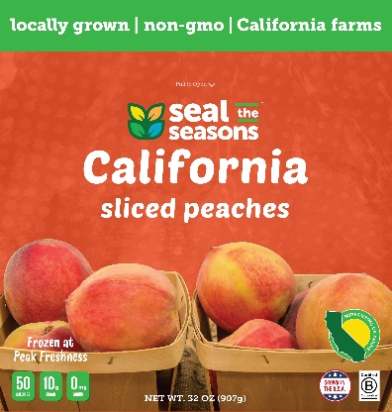
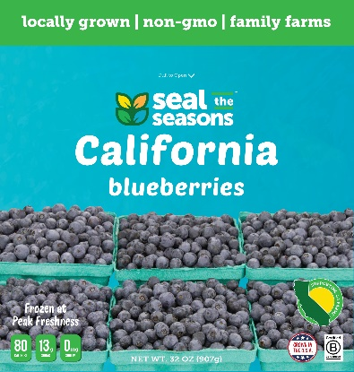
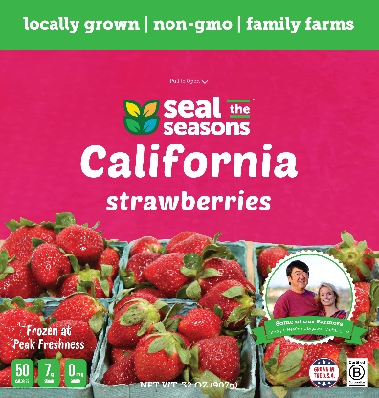

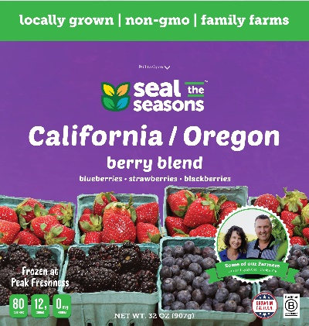
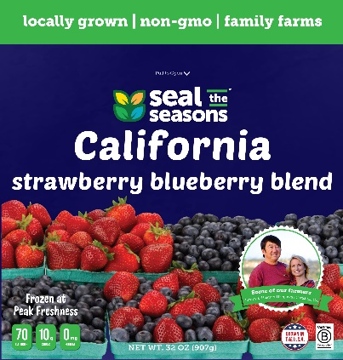

Seal the Seasons launches new LOCAL produce in Pacific Southwest
CHAPEL HILL, N.C. – Seal the Seasons is coming to the Pacific Southwest! The local frozen fruit brand has been authorized for distribution in California and Arizona-based retailers. They will launch five top-selling products in the winter and spring of 2019.
“We believe that locally-grown products are better for our planet, our economy and our taste buds,” said Seal the Seasons founder Patrick Mateer. “It made no sense to me that with such great produce grown right here in California I would walk into the frozen section and see that most of the frozen fruit was being imported from outside of the United States.”
Seal the Seasons has exploded across the United States in the past year, adding 20 states to its distribution in the East Coast, West Coast and Great Lakes. By February of 2019, local frozen fruit will be available in more than 3,000 conventional and natural retailers, a 400 percent increase from the previous year.
Seal the Seasons is the first company to sell local and regionally-grown frozen fruit in grocery stores 365 days a year. Until recently, frozen fruit sold in the United States was typically grown all over the world and imported for sale. Frozen strawberries often come from Turkey, Egypt, Serbia, Peru and Mexico, while frozen blueberries come from Chile, the Philippines, Ecuador and Canada. Seal the Seasons buys fruit from American farms that are as close to retailers as possible.
Their new California-grown product line includes: California Blueberries, California Strawberry Blueberry Blend, California Strawberries, California Peaches and California/Oregon Berry Blend (Blackberries, Blueberries & Strawberries).
Seal the Seasons mission is to bring affordable, high quality, locally-grown frozen fruit to grocery stores 365 days a year. Seal the Seasons envisions a world in which consumers have access to locally-grown food in every aisle of the grocery store year-round.
Small family farms have been closing at an unprecedented rate since the turn of the millennium. In the past 19 years, approximately 21 percent of small family farms have been forced to close their doors. “Seal the Seasons pays our growers a flat fee per pound that helps them make reliable money, regardless of what the market price may be,” said Procurement Specialist Keirstan Kure.
For more information about Seal the Seasons, contact Elizabeth Robins via email at elizabeth@sealtheseasons.com and by phone at (919)-245-3535 ext. 108. For the latest updates, make sure to follow @SealtheSeasons on Twitter and Seal the Seasons on Facebook.
About Seal the Seasons:
Seal the Seasons sells fruit on a state-by-state and region-by-region basis. Seal the Seasons currently sells North Carolina and South Carolina product in the Mid-Atlantic (North Carolina, South Carolina, Virginia, Georgia, Maryland and Tennessee), New York and New Jersey product in the Northeast (New York, New Jersey, Connecticut, Pennsylvania and Delaware), Oregon and Washington product in the Pacific Northwest (Oregon and Washington), and Michigan, Ohio and Wisconsin product in the Midwest (Michigan, Ohio, Kentucky, Illinois, Indiana and Wisconsin).
Retail partners in the Mid-Atlantic include: Harris Teeter, Ingles Markets, Lowes Foods, Food Lion, Whole Foods and The Fresh Market. In the Northeast, Seal the Seasons is sold in ShopRite and Whole Foods and in Safeway-Albertsons Portland in the Pacific Northwest.
Seal the Seasons originated in North Carolina, where the company worked with family farmers to freeze their produce in season and take it to market 365 days a year. Seal the Seasons frozen fruit first hit the shelves in September of 2016.
As a Certified B Corporation, Seal the Seasons is committed to using business as a force for good in the world. Its mission is to build local supply chains to change the food system. For more information about Seal the Seasons, visit www.sealtheseasons.com.
###

